Ex. No. 3 | ADD INTERACTIVITY TO APP – INPUT AND FORMS
Date of Exercise
GitHub Host Link | https://github.com/Urk23cs1272/flut-exp3.git

Aim
To create an interactive Flutter student registration form with input fields, form validation, and a submit button.

Description
This experiment demonstrates how to create an interactive form in Flutter using Form, TextFormField, GlobalKey<FormState>, and ElevatedButton. The form accepts student name, email, and password. Validation messages are displayed when required fields are left empty.

Procedure:
- Create a new Flutter project using the command: flutter create student_form
- Open the project folder:

cd student_form code.
- Open the lib/main.dart file.
- Create a GlobalKey<FormState> to manage form validation.
- Create a Form widget and assign the form key.
- Add a TextFormField for entering the student name.
- Add an email input field using TextInputType.emailAddress.
- Add a password field using obscureText: true.
- Add an ElevatedButton for submitting the form.
- Use the validate() method to check the entered information.
- Display a success message using SnackBar when the form is valid.
- Run the application and test the validation by clicking Submit without entering any information.

Program
import 'package:flutter/material.dart'; void main() {
runApp(const StudentFormApp());
}

class StudentFormApp extends StatelessWidget { const StudentFormApp({super.key});

@override
Widget build(BuildContext context) { return MaterialApp( debugShowCheckedModeBanner: false, home: const StudentForm(),
);
}
}
class StudentForm extends StatefulWidget { const StudentForm({super.key});

@override
State<StudentForm> createState() => _StudentFormState();
}

class _StudentFormState extends State<StudentForm> { final _formKey = GlobalKey<FormState>();

@override
Widget build(BuildContext context) { return Scaffold(
appBar: AppBar(
title: const Text('Student Registration'),
),
body: Padding(
padding: const EdgeInsets.all(20), child: Form(
key: _formKey, child: Column( children: [
TextFormField(
decoration: const InputDecoration( labelText: 'Student Name', border: OutlineInputBorder(),
),

validator: (value) {
if (value == null || value.isEmpty) { return 'Enter student name';
}
return null;
},
),
const SizedBox(height: 15), TextFormField(
decoration: const InputDecoration( labelText: 'Email',
border: OutlineInputBorder(),
),
keyboardType: TextInputType.emailAddress, validator: (value) {
if (value == null || value.isEmpty) { return 'Enter email';
}
return null;
},
),

const SizedBox(height: 15),

TextFormField( obscureText: true,
decoration: const InputDecoration( labelText: 'Password',
border: OutlineInputBorder(),
),
validator: (value) {
if (value == null || value.isEmpty) { return 'Enter password';
}
return null;
},
),

const SizedBox(height: 20), ElevatedButton(
onPressed: () {
if (_formKey.currentState!.validate()) { ScaffoldMessenger.of(context).showSnackBar( const SnackBar(
content: Text('Form submitted successfully'),
),
);
}
},
child: const Text('Submit'),
),
],
),
),
),
);
}
}

Output

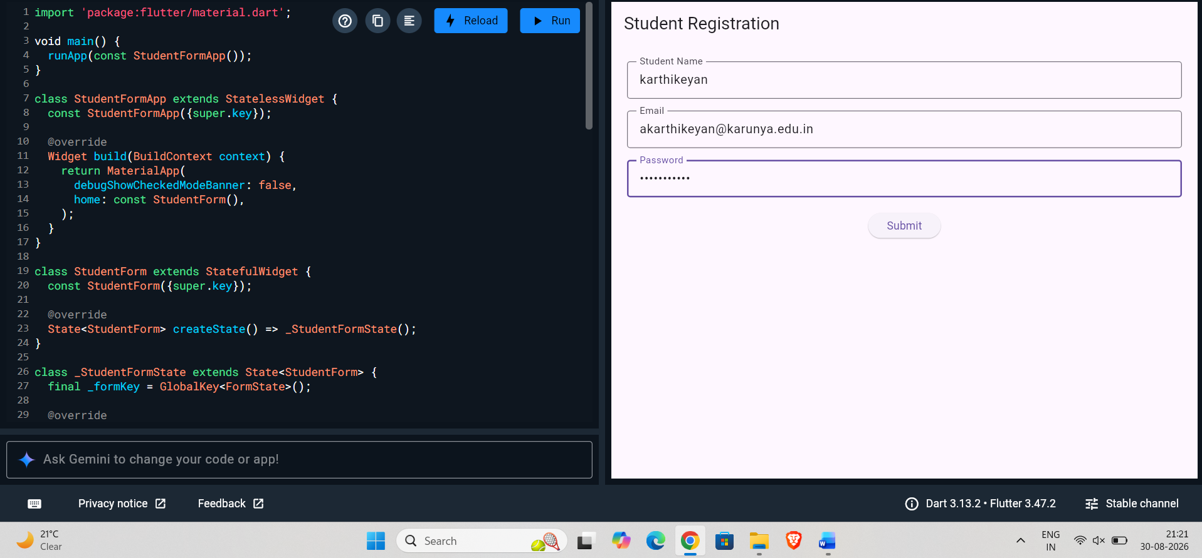

Result
Thus, an interactive Student Registration Form was successfully created using Flutter. The application contains Name, Email, Password, Validation, and Submit Button, and displays appropriate validation messages for empty fields.

